# CHAPTER 4: RESULTS AND ANALYSIS

## 4.1.0 Introduction

In this chapter the results that were obtained from the implementation of the system will be analyzed. The data will be shown in tabular form as well as graphs.

## 4.2.0 Model Summary

At first, we have summary of what the model does as well as the parameters --------- shown in the table below.

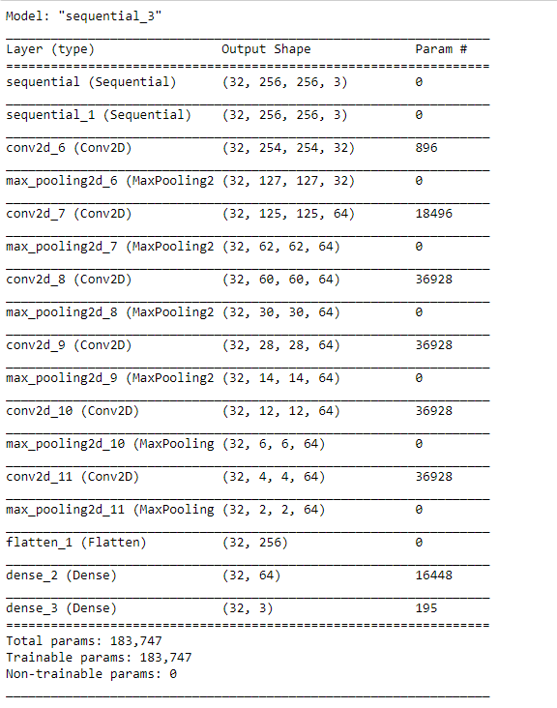

Figure 21

## 4.3.0 Model Training Results

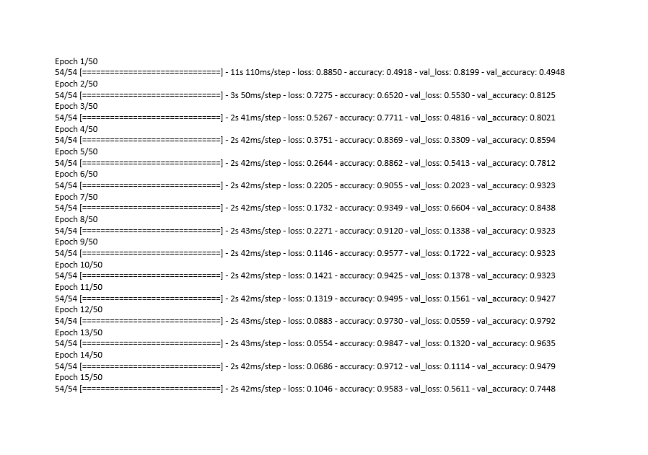

Figure 22

Figure 23

Figure 24

Figure 25

Figure 22, 23, 24 and 25 show the accuracy, loss as well as validation accuracy of the model that were obtained during training. During training the model iterated through the training dataset and accuracy improved significantly from 0.4918 to 0.9859 for the last image. The loss, however fluctuated but generally decreased from an initial value of 0.8850 to a lower final value of 0.0353. These trends are shown in graph form below on figure 26.

Figure 26

## 4.4.0 Model Test Results

After training, the model was then trained on the designated test dataset. The test dataset had to be unique to avoid testing the model on the exact images on which the model had been trained on. The model had an overall accuracy of 98% as shown in figure 27 below.

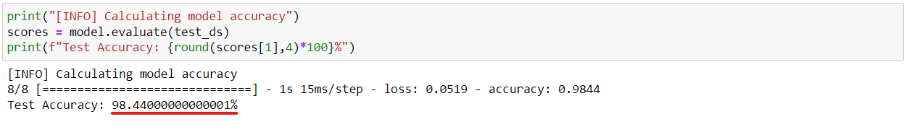

Figure 27

## 4.5.0 Summary

The Convolutional Neural Network based model performed well and was able to classify the tomato plant leaves with a high degree of accuracy (confidence).

# CHAPTER 5: CONCLUSION AND FUTURE RECOMMENDATIONS

## 5.1.0 Introduction

The plant leaf disease detector system was a success thereby integrating and implementing artificial intelligence in the farming sector. Based on the results obtained and the analysis carried out the disease detection system can be implemented on a small to medium sized plantation or farm.

## 5.2.0 Recommendations

* The system can be trained on a variety of other diseases.
* The model can also be tweaked or modified such that it can work on several different crops to increase its scope of applicability.
* Hardware components can also be coupled with the system so that images are automatically uploaded periodically and the model scans through the images.
* Both the hardware and the software can be modified to add components that help pin-point the exact location on which a diseased leaf has been detected.

## 5.3.0 Conclusion

The system's intended goals and objectives were accomplished, and the model performed exactly as predicted. We now know that this system can successfully be implemented at any small farmed land in a farming plot or plantation and that it will increase output yield that farmers can harvest as a result of its success in securing crops from diseases and assisting with the early detection of the various plant diseases.

# References

|  |  |
| --- | --- |
| [1] | A. Karpathy, "Convolutional neural networks for visual recognition," 2016).. |
| [2] | Ciresan, D. C., Meier, U., Gambardella, L. M., & Schmidhuber, J, "Deep, bog, simple neural nets for the handwritten digit recognition," pp. 3207-3220, 2010. |
| [3] | LeCun, Y., Bottou, L., Bengio, Y., & Haffner, P, "Gradient Based leaning applied to document recognition. Proceedings of the IEEE," vol. 86, no. 11, pp. 2278-2324, 1998. |
| [4] | Hinton, G. E., Osindero, S., "A fast learning algorithm for deep belief nets," *Neural Competition,* no. 18, p. 1527–1554, 2006. |
| [5] | Krizhevsky, A., Sutskever, I., & Hinton, G. E, "ImageNet classification with deep convolutional neural networks," *Advances in neural information processing systems, Red Hook, NY: Curran,* p. 1097–1105, 2012. |
| [6] | Russakovsky, O., Deng, J., Su, H., Krause, J., Satheesh, S., Ma, S., ... Bernstein, M., "ImageNet large scale visual recognition challenge.," *International Journal of Computer Vision,* p. 211–252, 2015. |
| [7] | Simonyan, K., & Zisserman, A., "Very deep convolutional networks for large-scale image recognition.," *ArXiv preprint,* p. 1409.1556., 2014. |
| [8] | Hubel, D. H., & Wiesel, T. N., "Receptive fields, binocular interaction and functional architecture in the cat’s visual cortex," *Journal of Physiology,* p. 106–154, 1962. |
| [9] | LeCun, Y., Bengio, Y., & Hinton, G. , "Deep learning," *Nature,* pp. 436-444, 2015. |
| [10] | LeCun, Y., Bottou, L., Bengio, Y., & Haffner, P, "Gradient-based Learning applied to document recognition.," *Proceedings of the IEEE Conference ,* pp. 2278-2324, 1998. |
| [11] | Zeiler, M. D., & Fergus, R, "Visualizing and understanding convolutional networks," *s. In Proceedings of the European Conference on Computer Vision,* pp. 818-833, 2014. |
| [12] | Srinivas, S., Sarvadevabhatla, R. K., Mopuri, K. R., Prabhu, N., Kruthiventi, S. S., & Babu, R. V, "A taxonomy of deep convolutional neural nets for computer vision," 2016. |
| [13] | Hinton, G. E., & Salakhutdinov, R. R., "Reducing the dimensionality of data with neural networks," *Science,* pp. 504-507, 2006. |
| [14] | Larochelle, H., Erhan, D., Courville, A., Bergstra, J., & Bengio, Y., "An empirical evaluation of deep architectures on problems with many factors of variation," *Proceedings of the 24th International Conference on Machine Learning,* p. 473–480, 2007. |
| [15] | Bengio, D. Schuurmans, J. D. Lafferty, C. K. I. Williams, & A. Culotta, "Advances in neural information processing systems," pp. 1339-1347, 2009. |
| [16] | Deng, L., & Yu, D, "Deep learning: Methods and applications.," *Foundations and Trends in Signal Processing,* p. 197–387, 2014. |
| [17] | Srivastava, R. K., Greff, K., & Schmidhuber, J, "Highway networks," 2015b. |
| [18] | Simard, P. Y., Steinkraus, D., & Platt, J. C, "Best practices for convolutional neural networks applied to visual document analysis.," vol. 3, pp. 958-963, 2003. |
| [19] | Ning, F., Delhomme, D., LeCun, Y., Piano, F., Bottou, L., & Barbano, P. E, "Toward automatic phenotyping of developing embryos from videos," *IEEE Transactions on Image Processing,* p. 1360–1371, 2005. |
| [20] | Lawrence, S., Giles, C. L., Tsoi, A. C., & Back, A. D, "Face recognition: A convolutional neural-network approach," *IEEE Transactions on Neural Networks,* vol. 8, no. 1, p. 98–113, 1997. |
| [21] | Garcia, C., & Delakis, M. (2002), "A neural architecture for fast and robust face detection," *Proceedings of the 16th International Conference on Pattern Recognition,* p. 44–47, 2002. |
| [22] | Chopra, S., Hadsell, R., & LeCun, Y, " Learning a similarity metric discriminatively, with application to face verification.," *In Proceedings of the IEEE Conference on Computer Vision and Pattern Recognition,* pp. 539-546, 2005. |
| [23] | Muller, U., Ben, J., Cosatto, E., Flepp, B., & Cun, Y. L, "Off-road obstacle avoidance through end-to-end learning," *Advances in neural information processing systems,* p. 739–746, 2005. |
| [24] | LeCun, Y., Huang, F. J., & Bottou, L, "Learning methods for generic object recognition with invariance to pose and lighting," pp. 97-104, 2004. |
| [25] | Huang, F. J., & LeCun, Y, "Large-scale learning with SVM and convolutional nets for generic object categorization," pp. 284-291, 2006. |
| [26] | Ranzato, M., Poultney, C., Chopra, S., & Cun, Y. L, " Efficient learning of sparse," *representations with an energy-based model.,* p. 1137–1144, 2006. |
| [27] | Belkin, M., Niyogi, P., & Sindhwani, V., "Manifold regularization: A geometric framework for learning from labeled and unlabeled examples," *Journal of Machine Learning Research,* vol. 7, pp. 2399-2434, 2006. |
| [28] | Collobert, R., Sinz, F., Weston, J., & Bottou, L, "Large scale transductive SVMs," *Journal of Machine Learning Research,* vol. 7, p. 1687–1712, 2006. |
| [29] | Ranzato, M. A., Huang, F. J., Boureau, Y., & LeCun, Y, "Unsupervised learning of invariant feature hierarchies with applications to object recognition.," p. 1–8, 2007. |
| [30] | Salakhutdinov, R., & Hinton, G. E. , "Learning a nonlinear embedding by preserving class neighbourhood structure," p. 412–419, 2007. |
| [31] | Hinton, G. E, "Training products of experts by minimizing contrastive divergence," *Neural Computation,* p. 1771–1800, 2002. |
| [32] | Lee, H., Grosse, R., Ranganath, R., & Ng, A. Y, "Convolutional deep belief networks for scalable unsupervised learning of hierarchical representations," p. 609–616, 2009. |
| [33] | LeCun, Y., Kavukcuoglu, K., & Farabet, C., "Convolutional networks and applications in vision.," p. 253–256, 2010. |
| [34] | Kaggle.com, "Kaggle.com," [Online]. Available: https://www.kaggle.com/datasets/kaustubhb999/tomatoleaf. |
| [35] | "Plant Disease: Pathogens and Cycles | CropWatch," University of Nabraska, 2020. [Online]. Available: https://cropwatch.unl.edu/soybean-management/plant-disease. [Accessed 01 September 2022]. |
| [36] | S. Savary, L. Willocquet, S. J. Pethybridge, P. Esker, N. McRoberts, and A. Nelson, "The global burden of pathogens and pests on major food crops," vol. 3, pp. 430-439, 2019. |
| [37] | S.Vijayalakshmi and D.Murugan, "An Effective Approach for Diagnosis of Plant Disease using ELM," vol. 4, pp. 327-335, 2017. |
| [38] | A. Kumar, D. Kumar, and S. K. Jarial, "A review on artificial bee colony algorithms and their applications to data clustering," vol. 17, no. 3, pp. 3-28, 2017. |
| [39] | Karpathy A, Fei-Fei L, "Deep visual-semantic alignments for generating," *Proceedings of the IEEE Conference on Computer Vision and Pattern Recognition,* p. 3128–3137. |
| [40] | Tompson, J., Goroshin, R., Jain, A., LeCun, Y., & Bregler, C, "Efficient object localization using convolutional networks. In Proceedings of the IEEE Conferenceon Computer Vision and Pattern Recognition," *Los Alamitos, CA: IEEE Computer Society.,* p. 648–656, 2015. |
| [41] | Ivakhnenko, A. G., & Lapa, V. G., "Cybernetic predicting device," *New York: CCM Information Corp.,* 1966. |
| [42] | Srivastava, R. K., Greff, K., & Schmidhuber, J. In C. Cortes, N. D. Lawrence, D. D. Lee, M. Sugiyama, & R. Garnett, "Training very deep networks," *Advances in neural information processing systems,* pp. 2377-2385, 2015a. |
| [43] | Szegedy, C., Vanhoucke, V., Ioffe, S., Shlens, J., & Wojna, Z., "Rethinking the Inception architecture for computer vision," 2015. |